**Name: Athul S**

**Roll No:40**

**Batch:A**

**Date:22-03-2022**

**NETWORKING & SYSTEM ADMINISTRATION LAB**

**Experiment No.: 3**

**Aim**

You are given a computer with very low hardware resources it is to be used as a kiosk identify and install a suitable linux distribution you can simulate it in a virtual environment?

**Procedure**

**Step 1**

Install virtual box.

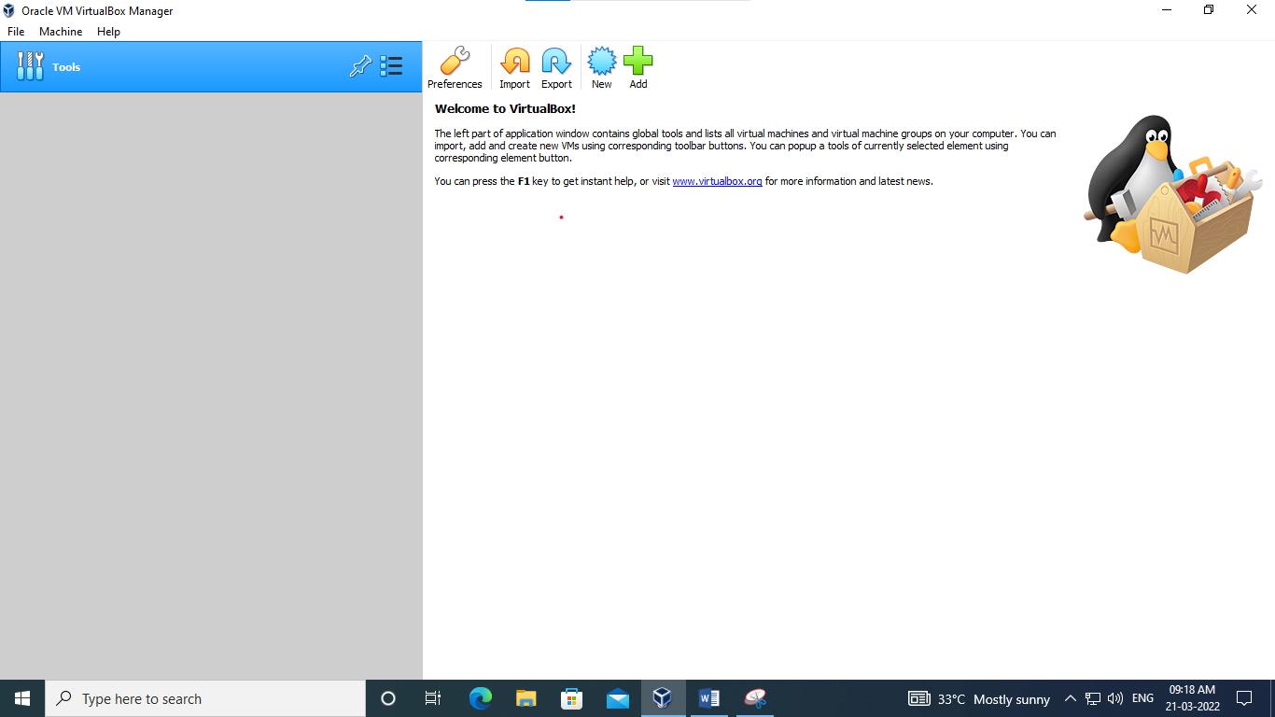

**Step 2**

Click new to add new operating system and give it a name.

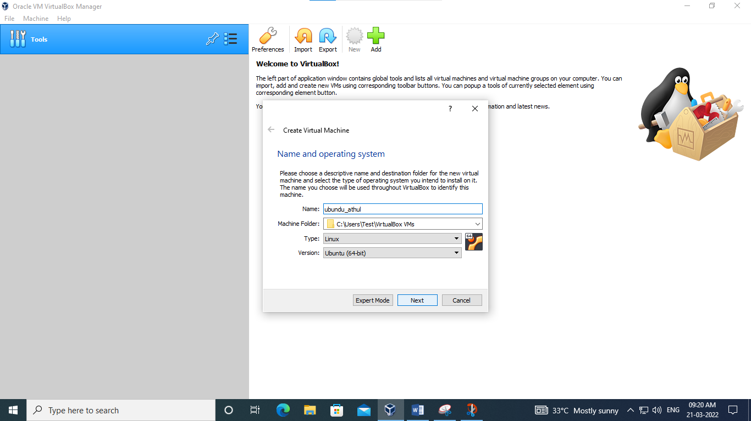

**Step 3**

Set size of ram required and create a virtual hard disk.

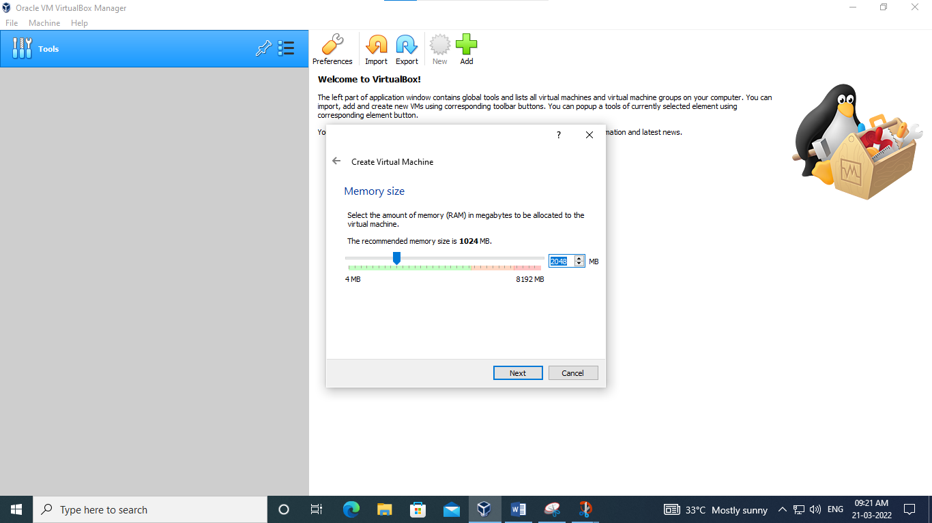

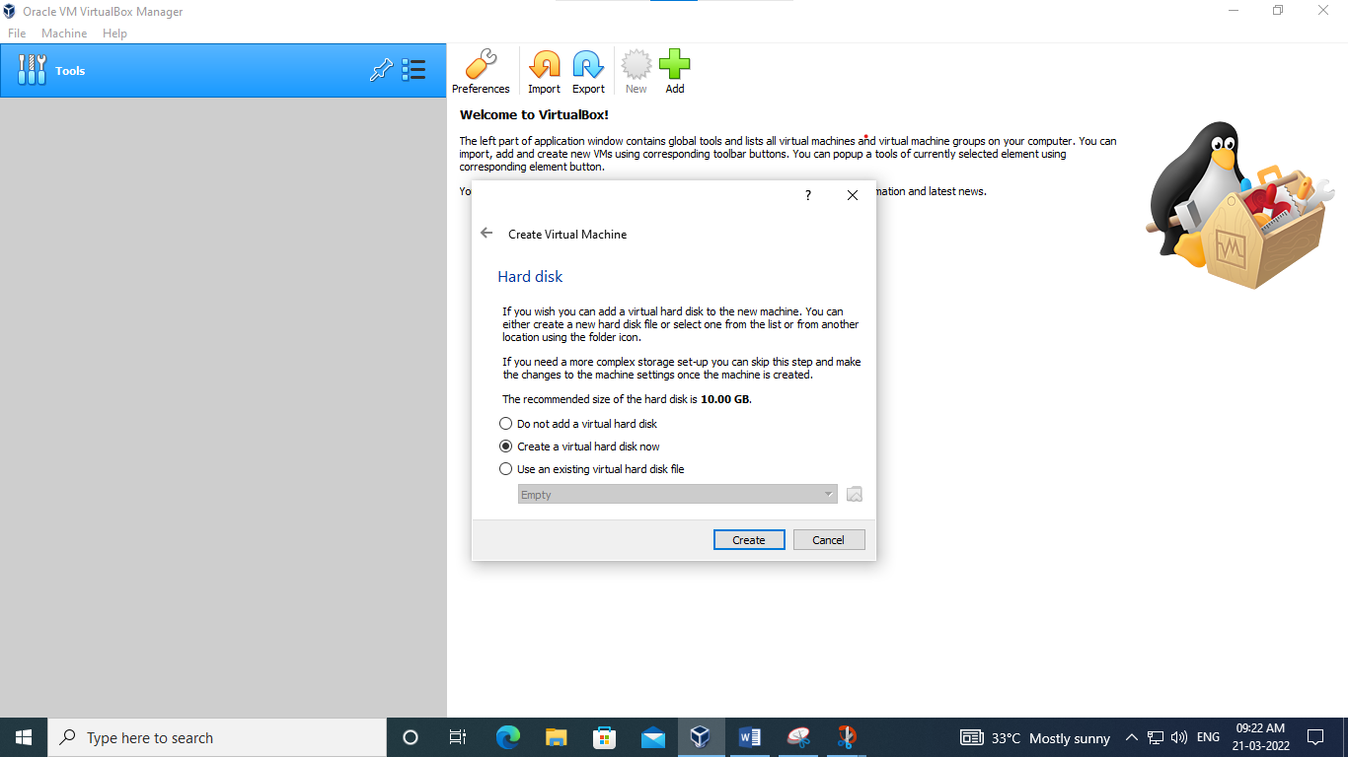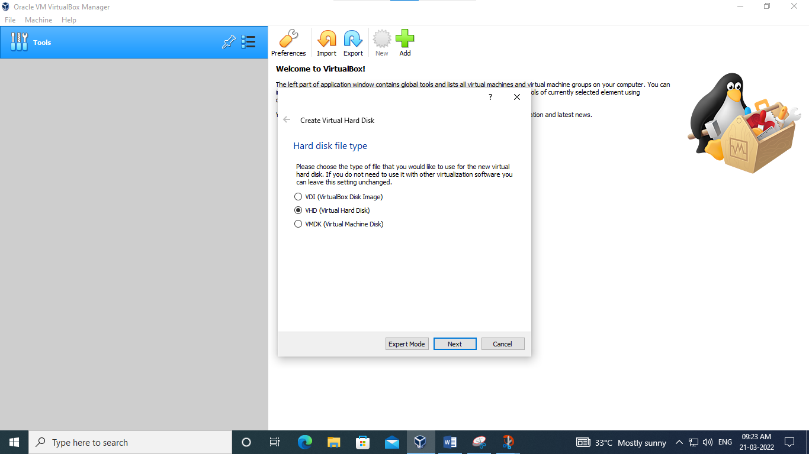

**Step 4**

Set memory type to dynamically allocated and add location of the iso file .

**Step 5**

Click the start arrow to run the os.

**Step 6**

Set your username and password

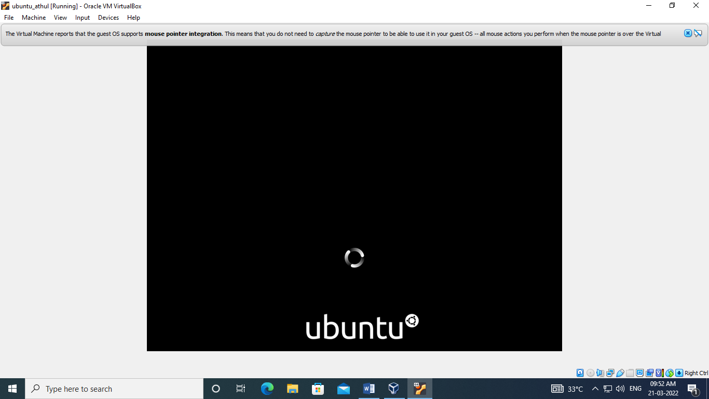

**Step 7**

Login to the user using your password.

